William James

Database Management

Rene German

12/16/2016

Hospital Data Management System Final Report

Hospitals are extremely important to our society and our healthcare industry. They make our lives much easier by helping people with every day illnesses and injuries, and frequently saving lives. Our society would not be able to function with hospitals. Hospitals often run into problems that take time to solve, these can be very inefficient and costly. Lives can be lost if problems like this occur. Many of these problems are a result of poor data management. Data management is important in any type of field or industry. It is imperative that there are as little data problems as possible, so companies or organizations can focus on what is important to them. It is important that hospitals can operate in the most efficient manner, to save money and use that money to focus on what is important, saving lives. For my final project, I have created a simple, yet efficient hospital data management system.

Hospitals often use paper to sort information, which can be very inefficient and costly. Data can also be lost or misinterpreted, and can be very tough to piece back together. Problems like these will hurt hospitals and can prevent them from helping people and saving lives. When these problems are kept to a minimum, hospitals can focus on saving lives and helping people. My hospital data management application will prevent problems like this from occurring. I have designed a simple and efficient data management system for hospitals. My application will minimize time spent search for records, which will save the hospital time and money. It will also make communication better between doctors, staff, and patients. This will prevent other problems that may occur due to human error.

Personally, I do not have much experience in the healthcare industry or with hospitals, but I enjoy helping people. Hospitals help people, so I thought it would be a good idea to do my final project on this topic. My sister, works as a physician’s assistant, and has told me that data problems often plague hospitals. Hospitals must waste money to fix these problems, and they would be better off if the problems were to never occur. I have also been told about bad experiences with data management problems from other families and friends. All this information that I learned from my friends and family, really made me want to figure out a solution to these problems. I believe my application can really help hospitals and save them money.

In a nutshell, my application will be able to search, print, insert, and delete hospital data. There are five main tabs in my application that the user can search, insert, delete, and generate csv files from. They are Patient, Doctor, Staff, Treatment, and Room. Some data in each tab relates to data from other tabs, and errors occur if data is not correctly entered. This prevents data being entered that will cause problems for the hospital. There is also a main tab, that explains what my application does, and guides the user to use it correctly. My project was created using java FX as a front end, and MYSQL as a back end. I used IntelliJ Idea for the java code, and Data Grip for MYSQL.

When researching about hospital data management systems, I found it important that they are simple to use and easy to understand. My hospital data management system has nine main tables that hold relevant information. They are: patient, doctor, staff, treatment, room, medicine, department, disease, and hospital. My relational schema is as shown in the diagram below, to help understand how they are connected.

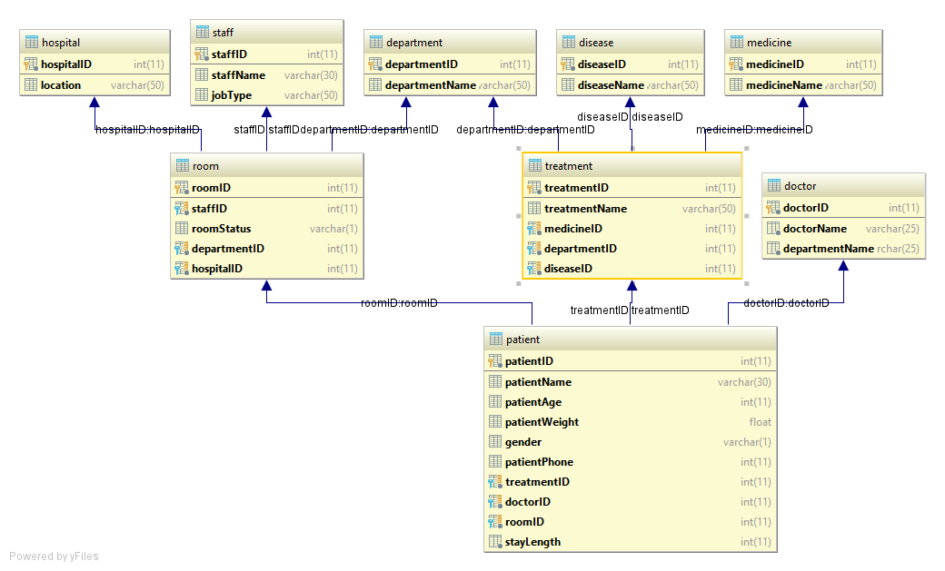

I used foreign key constraints to prevent data from not being relevant and make sure referential integrity took place. It took me a while to properly understand how they work with my database, but now I know how important they are. Indexes really helped speed up the time of searches in my application and helped it be more efficient. I had a tough time figuring out how they would work with my project, but learned a lot in the process. Views helped simply my data and present it as if it were coming from one table, when really it was coming from mulitple tables.

I found inserting and deleting data to be the easiest aspect of the project and learned alot about how hospital insert/delete data. Updating data was more challenging, as it is very important when it comes to hospital data. I spent a lot of time making sure my update functions would work well with hospital data. When generating the csv files, I used inner joins to get information from different tables, then group by statements to group the information. I used sub queries and prepare statements for my other csv files, which I found to be challenging to incorporate with my data. I have attached an example of what my doctor and patient csv files will look like. The patient.csv is on the right, and the doctor.csv is on the left. The other three csv files look very similar to these two, just with different information from different tables.

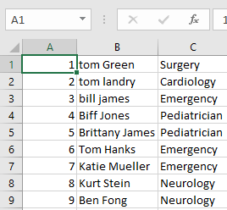 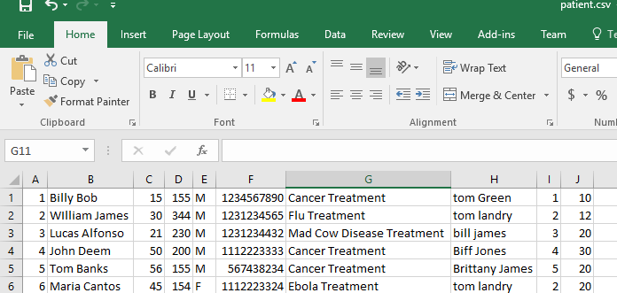

I have not had any experaince with Java FX, but found it to be a very helpful and an easy to learn langauge. Since I am new to building applications, my gui does not look special or anything. I also felt that hospital data management applications should not have fancy gui’s, but rather have a look simple and be efficient in its job. There are six tabs in my application, five of them have usability, and the main tab is just information for the user. These tabs are Patient, Doctor, Staff, Treatment, and Room. I have attached pictures of what they look like below.

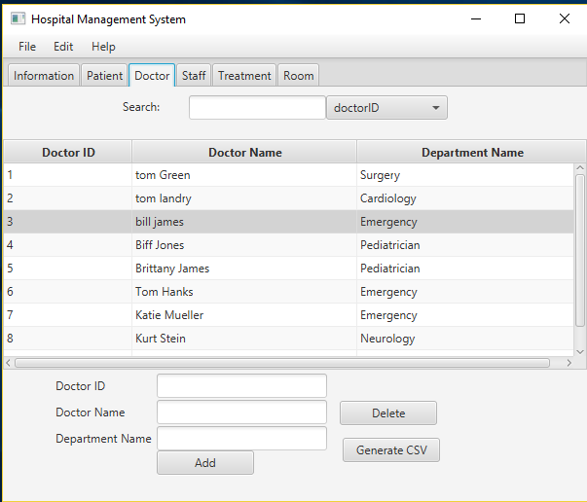 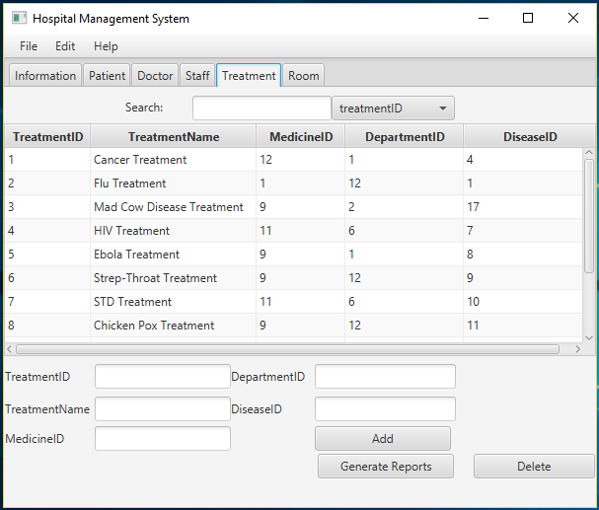

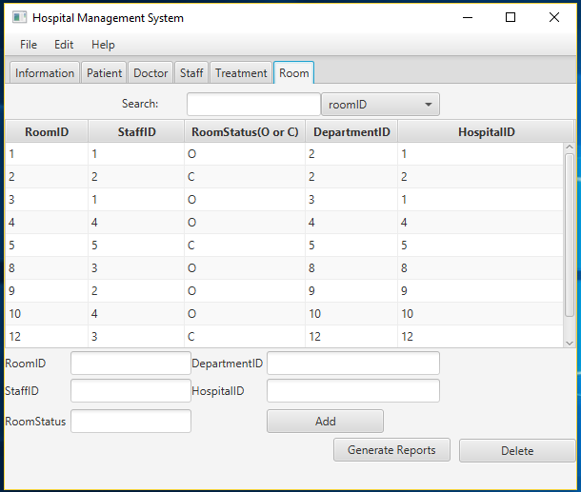 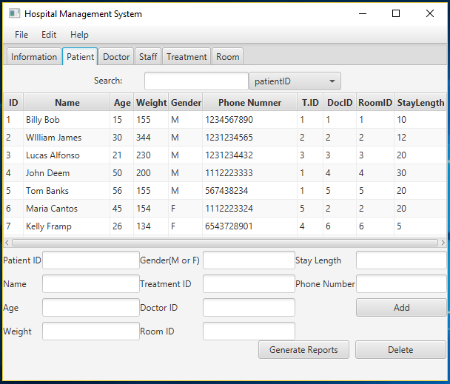

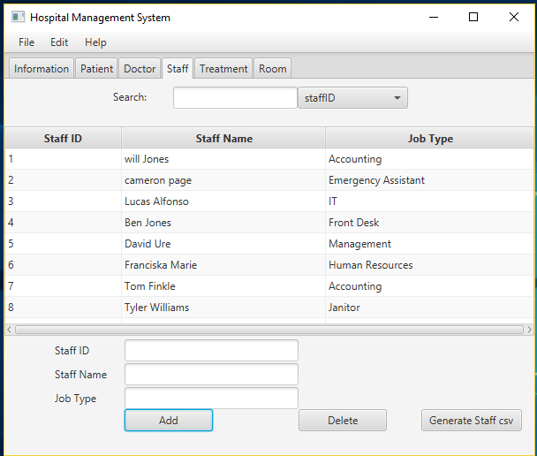

Since there was a limited time to complete the project, there are some small things that I was not able to finish in time, that I wanted to. However, my application does simply and efficiently help the user insert, delete, search, update, and print(into csv) hospital data, while including things we have learned in class this semester. I learned a lot from this project, and believe that it has made me a better coder, and application builder. I believe I can use what I have learned from this project to help me succeed in life. Overall, this project was very challenging, but also rewarding, and I believe my hospital data management system has the potenital to help hospitals in many ways.